Appendix 2 – Case Studies

Allotment Project

The Youth Ambition Programmes has built a partnership with Oxford Academy School, which serves the Blackbird Leys; Littlemore and Rose Hill communities. One of the projects is an allotment project with students at risk of being excluded from school because of poor behaviour.

Our staff worked with 5 year 9 students to plan what fruit and vegetables they wanted to grow, what they wanted the allotment to look like; what they wanted to do with the produce and what accreditation they want to get out of it.

The students chose a mixture of fruit and vegetables, including a herb garden; salad patch; vegetable patch and having a pumpkin competition. Once the produce was grown they used the produce to cook a huge roast dinner. The students are working towards a qualification.

The impact of the project has been considerable, with one student Owen, saying: “I find school really difficult, so I mess around a lot, but doing the allotment has shown me I’ve got loads of practical skills. I want to be a gardener when I’m older now! I go to the Youth Ambition youth club in Littlemore now as well!”

Tom Peterson, Oxford Academy School’s Community Liaison Manager said: “the project with the City Council has been first rate. The staff have worked with students and taught them important life skills and knowledge such as project planning; team work; health and safety and practical skills. The fact that the staff will be willing to provide references if the students do well means this project could help the boys get jobs when they leave school.”

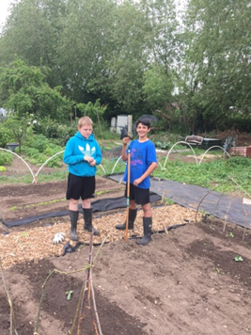

Children in Need Fundraiser
To raise money for children in need young people organised a football tournament at Leys Leisure and Pools.

The young people paid £1 to enter and food was sold for £1 afterward, which was made by young volunteers. We also watched children in need on the centre TV.

40 young people aged 10-19 took part in the tournament and the winners won tickets to a professional football match, which were donated by Oxford United.

It was a really successful night, with one young person commenting “It was good to get together, play football and raise money for charity.”

The total raised was £336.

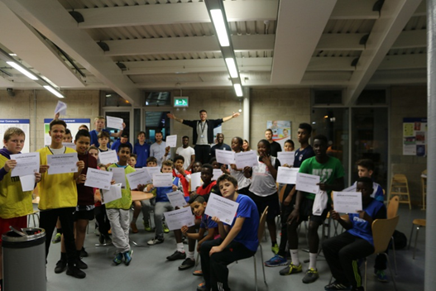

Step Out at Donnington Doorstep (funded by Youth Ambition)

Young Person 1’s journey so far (over the last 12 months) by the STEP OUT project.

Young Person 1’s mum contacted the statutory Kingfisher CSE team to ask for support for her daughter, as Young Person 1 did not meet the threshold for Kingfisher they contacted the STEP OUT project to provide support.

STEP OUT visited mum to establish her worries and concerns, some of these included Young Person 1 hanging around with others who were missing, drinking alcohol, spending time with young men of concern, missing from school and a lot of online activity.

Young Person 1 does not trust authority / workers so it took some time to try and build a relationship, so when Young Person 1 refused or did not want to meet at the beginning, a card or note was left for Young Person 1 explaining what support is offered. There was regular messaging/compassion banking at least once a week, to build on a relationship.

After some time, Young Person 1 agreed to meet. The first session involved an explanation of the STEP OUT project, the child protection and safeguarding policy to establish information sharing boundaries to enable Young Person 1 to feel safe. Time was then given for Young Person 1 to decide if she would like to receive support from STEP OUT or not, consent was gained and support began.

Soon after, social care became involved to do an assessment, a multi-agency risk management plan meeting took place and it was decided a longer term social worker would become involved to provide support. Other agencies were also involved. However, Young Person 1 refused to meet with a number of social workers as she found it difficult to trust authority, including teachers. STEP OUT have been able to take the time to build a trusting relationship to be able to provide 121 support to raise awareness about, healthy relationships, keeping safe, risks and talking through other worries such as concerns at home. STEP OUT have also been a part of the multi-agency team working with Young Person 1 and shared information with the police, social care and other agencies when relevant.

Risks have included getting into cars with young men, drinking alcohol, truanting and missing from school, theft, underage sex without contraception, non-consensual sexual activity, being pressured into sending inappropriate pictures (sexting). Being involved in friendships / relationship where the boyfriend has been emotionally controlling and manipulative. Other difficulties have been related to family relationships at home, historic domestic violence with parents, change of schools and being unable to see risks.

The resources and 121 sessions are planned but also adapted to the needs of Young Person 1 in that moment, so having a number of resources to hand is essential. For example, the resource “Barnardos BeWise 2 sexual exploitation” regarding the grooming process, “healthy relationship by Solihull Council”, film material and online resources used by www.thinkuknow.Co.uk and CEOP (Child Exploitation Online Protection) have been valuable resources.

Some sessions have included the police on legal issues such as the consequences of sexting. Other sessions have included support to attend sexual health Clinics to explore and advise on sexual health concerns, such as the different types of contraception. STEP Out have also advocated on Young Person 1 behalf during multi-agency meetings and with her parents where there are difficulties and strong emotions at home.

Young Person 1 attendance at school has and continues to improve. Young Person 1 is able to talk through her frustrations about her family relationships in a safe way with her STEP OUT worker which help to reduce the likelihood of going missing and putting herself at risk. Young Person 1 is also able to continue to engage well with CSE awareness sessions whilst upskilling her knowledge in a comfortable environment, due to the trusting relationship she has with her STEP OUT worker.

Community Sports Leadership Award
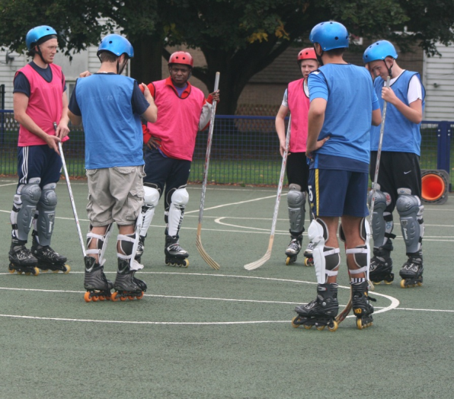
The Youth Ambition team coordinated a Community Sports Leadership Award, a 5 day intense course, aimed to teach the young people skills in organisation, planning, communication and teamwork. We identified 7 young people from Oxfords regeneration zones who highlighted not only commitment to the programme, but a passion and desire to develop their skills. These young people were given a free place on the course, alongside 1-to-1 support in order to complete their qualification and identify opportunities for volunteering and work within the community.

All of the young people who attended the course have now completed their qualification and are involved with coaching and volunteering at a number of sessions across the city. One of the young people described the course “A lot of the time I fantasise about what I am good at, and miss the things I need to work on. But this course really brought us out of our comfort zones and highlighted things about ourselves that we didn’t already know” he continued “I’m not as confident as I look, but I came out of my shell. I can do anything I put my mind to”

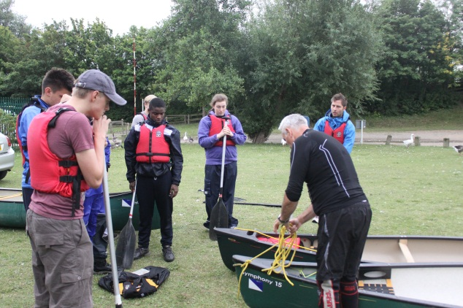
Another one of the young people that attended the course highlighted how he always intended to coach football at an elite level, however now has gained an interest in putting something back into the communities he grew up in. He acknowledged how he is already using the skills he learnt and has developed a passion for canoeing and skater hockey, two activities offered as part of the course.

Kam Raval who delivered the course commented “It’s not often I deliver a course where every one of the young people is as passionate, enthusiastic and willing to learn as this group. I am confident that these young people will go on to be great ambassadors for the next generation within their communities”

This Girl Can! These Girls Can!
We worked with the Year 11 girls at The Oxford Academy to develop a sports programme with a difference. Having received feedback from the girls it became apparent that the girls had become disinterested and disengaged from PE and school sport, they acknowledged how taking part in activities with the boys, the PE lessons and traditional sports were no longer attractive.

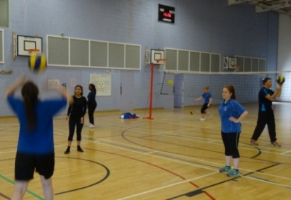
Thus we decided to form a small working group who met a number of times and discussed what the current barriers to participating in school sport are. The girls were very proactive and enthusiastic to get their points across highlighting that school sport was too serious, taking part with the boys was off-putting and that the school no longer offered sports that were appealing.

A number of the girls within the group really stood out and took a lead within the sessions, one girl was very proactive and took on the task of creating, printing, laminating and displaying posters and flyers around the school. The girls also developed an incentive scheme to encourage participation and this consisted of hair and beauty vouchers, which were used towards their prom at the end of term.

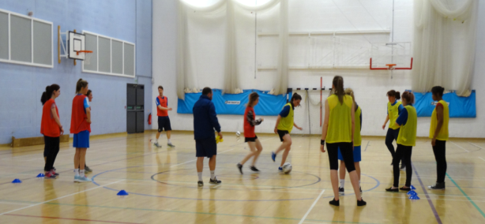
After a number of discussion sessions, the girls decided what sports they thought would be most appealing to the year group. We decided to go for 10 different sports which weren’t currently offered as part of the school’s sports programme, these included yoga, zumba, volleyball and boxercise. Originally the plan was to call the project ‘Get Fit for Prom’ however the girls were concerned that this may prove to be off-putting for some of the year group, therefore we decided to link it in with the Sport England campaign and coined the project ‘This Girl Can’

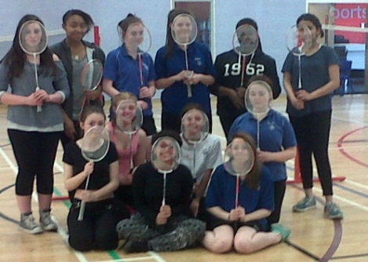
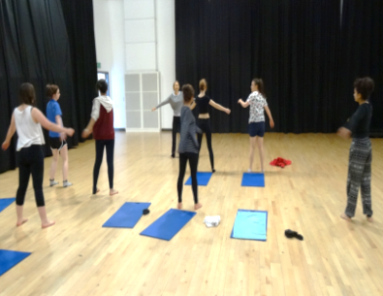
On the first week we had 18 girls turn up to the zumba session which was great, the girls all had great fun and were excited about to opportunity to take part in a number of sports they have never tried before. Over the coming weeks we managed to engage almost 30 year 11 girls and it became apparent that it was more than just a sports session. The girls were staying after the session to talk to our leader Nancy, and as a result we offered a number of talks across the 10 weeks which included self-confidence, revision and drugs and alcohol.

While we saw a dip in numbers during the last few weeks of the program as a result of the girls sitting their GCSE’s it was clear that the girls thoroughly enjoyed themselves. One girl noted “This Girl Can definitely boosted my confidence, and I had a lot of fun! I hate sports and physical activity but when you’re doing it with your friends it doesn’t seem as hard” Another young girl highlighted that before the project she was spending less than 1 hour a week on sport, while now she is doing between 6 and 10 hours per week, and that the project had improved her behaviour at school.

